**Data Visualizatoin for sample Hospital Data**

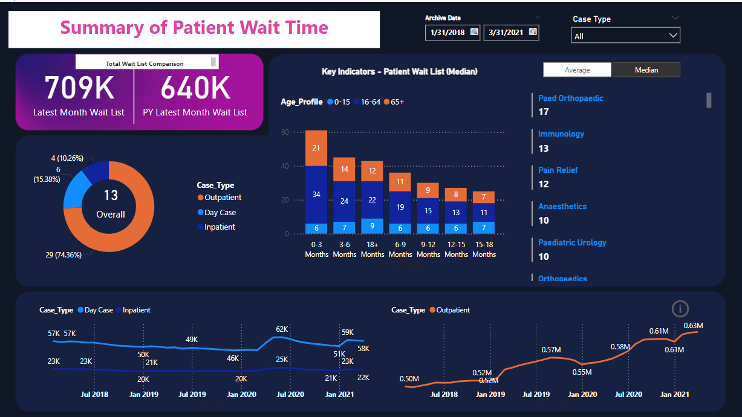

This Power BI Dashboard highlights the importatnt KPI for Average wait time using Average and Median techniques against sample data from a sample hospital.

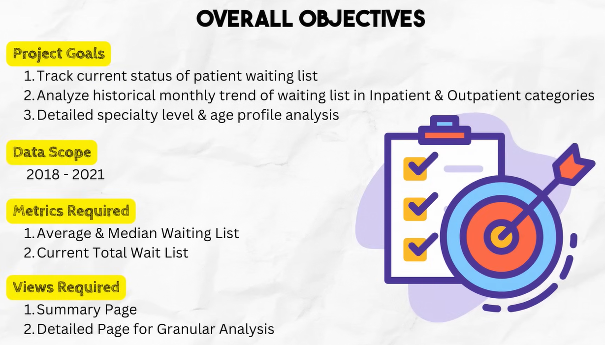

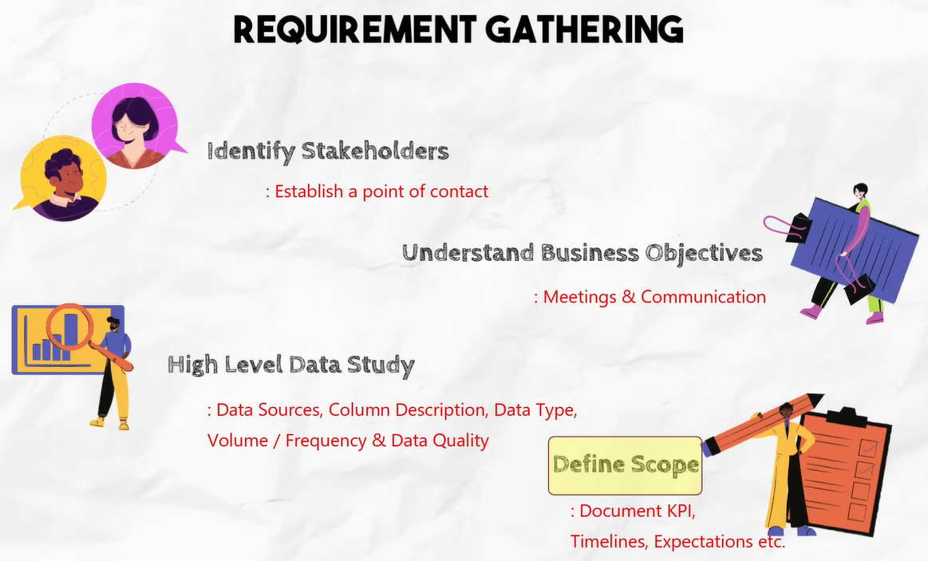

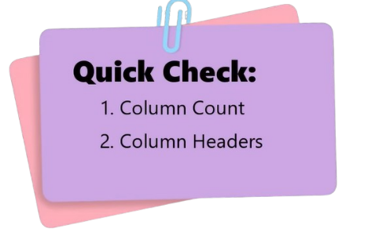**High Level Data Study 🡪** Take a bird’s eye view on data as what is inside it.

1. Data Sources
2. Column Description
3. Data Type
4. Volume and frequency
5. Data Quality – Missing Values or Anomalies

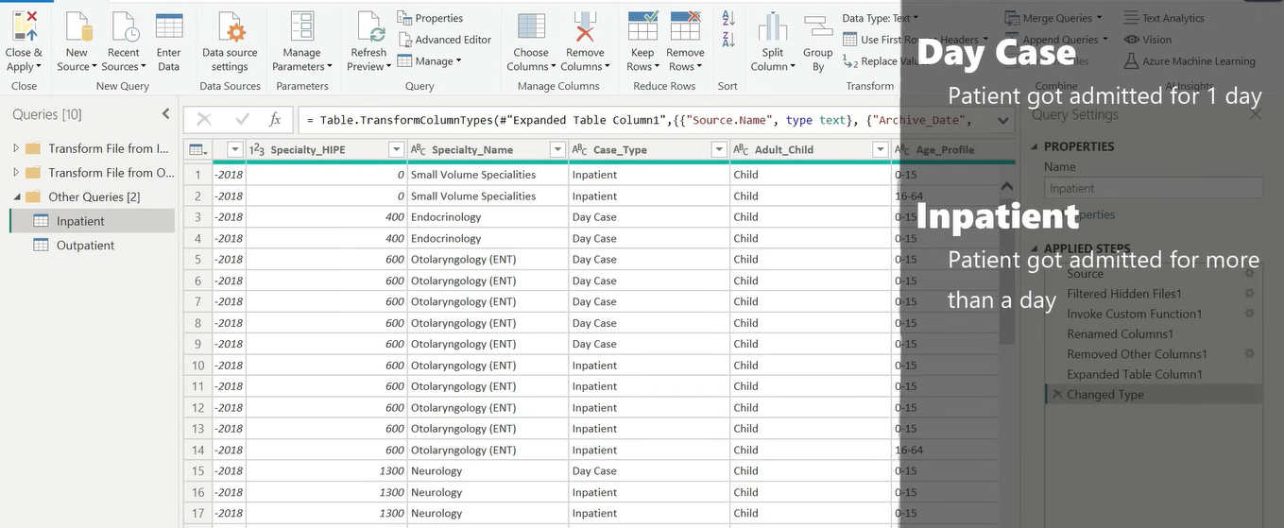

**Data Transformation**

1. Patients Age Groups against waiting list Renaming Columns
2. Rearranging Columns
3. Appending 2 Tables
4. Replacing & trimming values

**Renaming Columns**

1. While studying the data, I noticed that the Specialty column in Inpatient data is named as Specialty_Name, whereas in Outpatient it is named as just Specialty.
2. Case_Type which is missing from Outpatient. So lets create one additional column in Outpatient table called Case_Type

